Progress of X-Band Accelerating Structures
T. Higo#, KEK, Tsukuba, Ibaraki 305-0801, Japan
Abstract
In the present paper, we try to review the progress on high gradient X-band accelerator structures for linear colliders, especially highlighting the recent progress in realizing a high gradient acceleration gradient for CLIC.
The high gradient target value in LC structures has been upgraded from 65 MV/m as of 2004 to 100 MV/m for CLIC at present. In this paper are discussed mostly those related to this advancement. The nominal suppression scheme of the wake field today is heavily-damped one, different from the damped-detuned one as of 2004. This design choice affects the high-gradient performance and some experimental results are shown to discuss the possible parameters, pulse surface temperature rise, as one of the limiting factors.

Introduction
The X-band R&D for linear collider (LC) use has been studied for more than 20 years since late 1980. Projects relevant to this paper are listed in Table 1. The author would like to respect the early innovative developments by Russian VLEPP [1] targeting 100MV/m at 14 GHz, as the first stage of LC with almost X-band frequency. The X-band high-gradient accelerating structures have been extensively developed until 2004 in its second stage under GLC/NLC collaboration [2] targeting LC with 0.5~1 TeV. A 65MeV/m unloaded was established in 60cm structures for this [3]. The technology base for the present-day high gradient accelerating structures targeting for even a higher energy machine is also based on this technology in 100 MV/m regime. This is the third stage for the X-band developments for the LC enabling to reach a multi-TeV such as CLIC [4].
The early CERN-KEK-SLAC collaboration showed 100MV/m at 11.4GHz around 1994 [5]. This is based on the high-precision diamond turned structure. Diamond turning was extensively utilized to realize the damped-detuned structures for GLC/NLC. This is the second step for the X-band high gradient developments. In the prototype structures, we established 65 MV/m level with the reasonable breakdown rate in the wake-field suppressed structures. However in this stage, we already noticed the vulnerability of the copper accelerator structures running at several-tens of MV/m. This was discussed to be related to those such as power, group velocity, pulse surface heating, etc. in addition to the high surface electric field. Meanwhile, the re-optimization of the CLIC made a decision to cite the frequency of 12GHz [6]. It made the third stage for the X-band serving for LC. The collaboration framework among CERN-SLAC-KEK was re-organized and to date the effort to realize the field of 100 MV/m level in a shorter structures of typically 20cm long has been conducted under this framework.
Table 1: Accelerator structures for linear colliders.
Project | VLEPP | NLC | GLC | CLIC
Main institute | BINP | SLAC | KEK | CERN
Orig. / now (GHz) | 14 | 11.4 | 11.4 | 30 / 12
Eacc (MV/m) | 100 | 50 | 50 | 150
RF source | Kly | Kly | Kly | 2 beam
Structure length (m) orig. / pres. | 1 | 1.8 / 0.6 | 1.3 / 0.6 | 0.2~0.3
HOM suppression | UDS | DDS | DS / DDS | UDS / HDS
Kly=klystron, UDS=undamped, CZ=const. impedance

early LC to CLIC today

Structure Evolution
At the early stage of the LC, a high repetition rate machine in a single-bunch operation was adopted. Therefore, the structure design was straightforward without considering on the higher order modes (HOM). The VLEPP adopted 14 GHz 1m CZ structure as shown in Fig. 1.
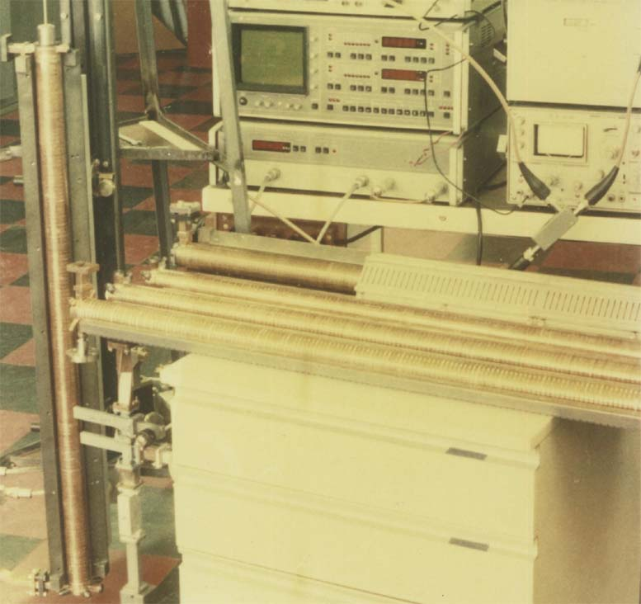
Figure 1: VLEPP accelerator structures in early 1990.
In this early era of LC history, people were optimistic in realizing the high gradient performance in the accelerator structures. Two X-band structures made by CERN, such as shown in Fig. 2, successfully reached 100 MV/m [5]. However, the criteria to judge the high gradient performance were not matured then. Ten years or so was needed for us to understand the importance and experimentally evaluate the breakdown rate and the sustainability of the structure.
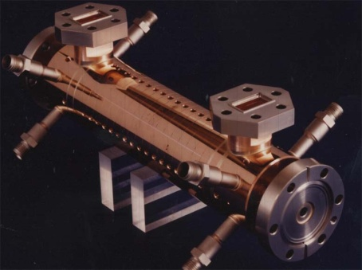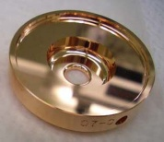
Figure 2: CERN made 30cm X-band accelerator structure.
The demand for higher luminosity and higher energy transfer efficiency made the LC design toward multi-bunch operation. The length of the structures also became long hoping to reduce the number of couplers to reduce cost. It finally reached 1.8m RDDS1 (rounded damped-detuned structure) as shown in Fig. 3. With the precision machining followed by the diffusion bonding to keep the precision, the wake field suppression was proved to be as designed. However, the cells comprising of the structure, shown in Fig. 3, has shape edges in various places and we assumed poor high gradient performance so that the high gradient test was not performed.
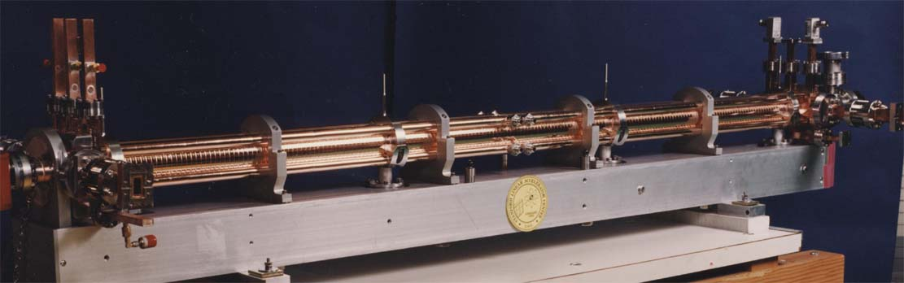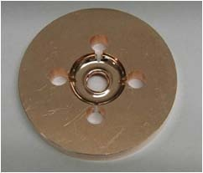
Figure 3: 1.8m RDDS1 structure and constituent cell.
These sharp edges were rounded and taking a high-phase-advance design to make the aperture large with keeping the small group velocity, the HDDS (high-phase advance DDS) with 0.6m length shown in Fig. 4 were designed as the nominal design for GLC/NLC. A number of the structures were rigorously tested at SLAC and KEK by the summer in 2004. In this stage, the breakdown rate (BDR) was carefully measured [3].
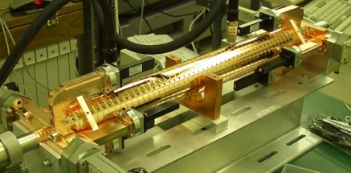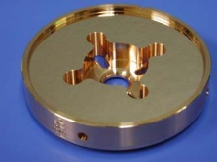
Figure 4: 0.6m HDDS structure and constituent cell.
Since 2007, CLIC nominal structure design became heavily-damped structure, HDS. The collaboration among three laboratories was established, in which the existing two high power facilities were utilized for the critical test on high gradient performance. Therefore, the CLIC prototype structures were made intentionally as a twin as shown in Fig. 5. Here the collaboration is by CERN design, KEK fabrication and SLAC bonding+baking [8].
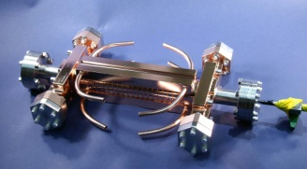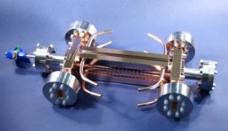
Figure 5: Prototype twin structures of T18. Left is for test at KEK and right for test at SLAC.

Evaluation of High-Gradient Performance
The idea for designing the accelerator structures to be operated at a very high gradient has been one of the main issues for realizing high energy accelerators. The most problematic issue is the vacuum discharge. The surface preparation based on diamond-turned high-purity oxygen-free copper and vacuum/hydrogen furnace process for bonding was found good for such high field in the early stage of the GLC/NLC liner collider program in early 90’s.
During the further advancement in ten years until 2004, the understanding of the importance of low group-velocity design was one of the general trends to reach high gradient. It made the structure length of 1.3 ~ 1.8m design with group velocity of a few to ten percents down to the length of 60cm with the group velocity of a few percent level. Another key point identified was the necessity to suppress the enhancement of the surface magnetic field. It was firstly noticed from the severe breakdowns near the input coupler with the sharp iris edge between waveguide and coupler cell [9]. We should admit that the mechanism was not completely understood but the suppression of H field by rounding such edges made the problem gone. The same features affected the high gradient performance of the early-stage damped-detuned structures (DDS) with sharp edge over the rim of damping slots [10]. Through these cares, the accelerating gradient of 65 MV/m unloaded was established [11,12].
The demand of LC main linac reachable to a multi-TeV range in its center-of-mass energy, the CLIC set originally the nominal gradient at 150MV/m at 30 GHz. Though it reduced the gradient and frequency to 100 MV/m and 12GHz through the further optimization process including efficiency and cost point of view [6], it was still a challenge beyond the previously established level in the stable high gradient performance point of view.

Finding Parameters Governing Gradient Limit
To address this high gradient, A. Grudiev [13] compiled many of the experimental results scaled to the pulse width 200 nsec and BDR of 1x10⁻⁶ /pulse/m. The parameter, complex pointing vector, Sc, was proposed. It describes the energy transfer to the field emission tip to further enhance the emission and heating of the tip which may eventually grows into the macroscopic breakdown which we usually observe. If we plot the square root of the Sc values for most of the recent accelerator structures in one plot, all of the points stay within a factor 2, including 11.4GHz and 30GHz, 20 ~ 60cm length, travelling wave structure and standing wave cavity, heavy-damped structures and un-damped ones, and phase advance from 60 to 150 degrees/cell. It seems this quantity serves as an estimate of the reachable gradient of the structures in a wide range of designs.
Another important parameter is the pulse heating temperature rise, ΔT, the surface temperature rise within an RF pulse. From a large number of single-cell cavities were tested at SLAC [14], it was found that the breakdown rate was governed by ΔT rather than the surface electric field.
Taking these parameters, such as Sc and ΔT, related to the recent phenomenological understandings of the high-gradient performance into account, the present CLIC prototype structure was designed which is aimed at accepting both the heavily damping feature and high gradient stability. The understanding of these parameters is one of the major advancement of the recent structure research and developments.

Cell Shape Design Evolution
Most of the structure for recent LC designs are with damping features of higher-order modes, the equivalent Q values ranging from 10 to 1000~2000. Most of them take the damping mechanism of magnetic coupling from cell outer wall. This choice makes the local magnetic field enhancement and increase ΔT so that it may deteriorate the high gradient performance. The establishment of the stable high field in such heavily-damped structures is one of the main issues of the present CLIC accelerator structure development. Typical such cells are shown in Fig. 6 (right).
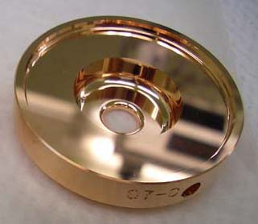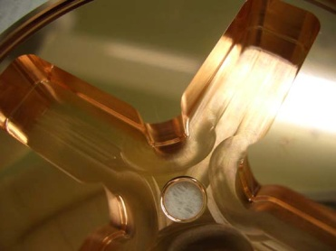
Figure 6: Typical disk-shape cells. Left: undamped cell and right: heavily damped cell with magnetic coupling.
Another idea, the choke-mode cavity, to heavily damp the higher modes was proposed in the very early stage of the LC development and was already adopted in the actual linac [15]. However, there are some considerations needed, such as the efficiency drop due to the choke itself, possible multipacting over a narrow gap. The design based on choke mode is in progress.

Fabrication Technology
There are two ways of constituting a structure with building blocks, one with dividing longitudinally into rods axis and the other with slicing transversely into disks. The former one was originally proposed for CLIC at 30GHz and is studied in the X-band as one of the methods. An example is shown in Fig. 7 [16]. There is an opinion that this way of fabrication is cheap comparing to the disk-based one, though the high gradient stability and the alignment issues are to be confirmed.
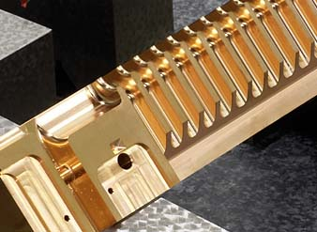
Figure 7: Quadrant close up view.
The fabrication of structures with more than one meter long was established for GLC/NLC structures [11]. The constituent cells are precision machined and chemically polished by the standard SLAC procedure on copper. These are diffusion bonded and finally vacuum baked at 650 degC confined in a vacuum can being evacuated independently of the furnace vacuum. In recent years, the LC structure design moved into much shorter one, such as 20cm, but the same fabrication technology is applied as the nominal procedure to make them [12]. In this sense, no big change exists in the fabrication technologies.

High gradient performance
One of the major advancement related to the accelerator structures is the proof of the operation at a high gradient of 100 MV/m level.

High Gradient Tests in Prototype Structures
At present, there exist three major facilities for the high gradient test aiming at evaluating CLIC prototype structures. The NLCTA and ASTA of SLAC [17] and the Nextef of KEK [18]. The fourth one, CTF3, is being established at CERN [19]. All these are tuned now for the CLIC prototype structure tests.
It is healthy to compare the same-quality accelerator structure in multiple places independently. We usually make a pair of structures with the same design and fabrication method to be tested at NLCTA and Nextef. Some example of such pairs are shown in Figs. 5 and 8.
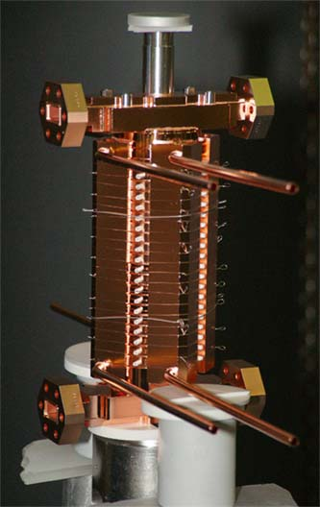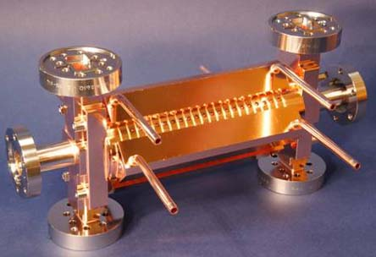
Figure 8: Prototype twin HDS structures, TD18. Left: brazing setup of that for test at KEK, and Right: equivalent one as of completion for test at SLAC.

Breakdown Rate
The availability of the luminosity machine is largely affected by the BDR of the constituent accelerator structures. This value has been evaluated seriously since early 2000 to judge the feasibility of the structures. In Fig. 9 are plotted some BDR data vs. acceleration gradient. It was found in an early undamped structure, T53, that it could be operated at 100 MV/m level with a short pulse width of 100 nsec. It was also found in even a DDS structure, H75, that it could be operated at the similar level. However, the BDR of the nominal high-phase-advance damped-detuned structures, HDDS, named as KX01 and KX03 here, operated at the nominal pulse width of 400 nsec showed higher BDR, though showing the feasibility of at least 65 MV/m which was the target for them. From these examples, we see a feasibility to operate at 100 MV/m range with these copper structures.
The BDR shown above operating at 100 MV/m regeme are all in the structures without heavy damping on HOM. In Fig. 10 are shown the BDR’s comparing those of undamped and those damped [8, 20]. As shown in the figure, it showed the different BDR by more than two orders of magnitude. Since the BDR changes as function of processing time, the BDR of damped structure in this case was still approaching to the undamped one but still an order of magnitude higher after another thousand hour operation.
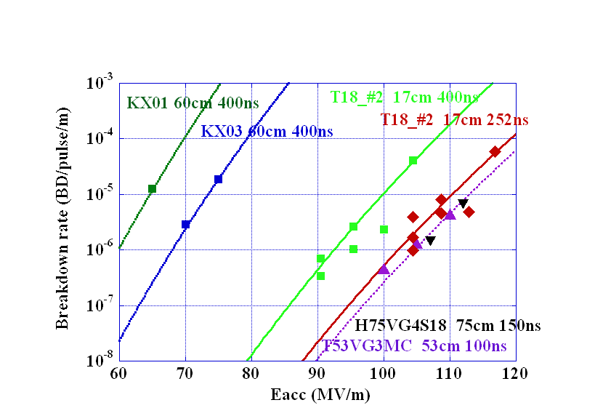
Figure 9: Breakdown rates of 53cm undamped structure, 60~75cm HDDS structures and undamped 20cm CLIC prototype structures, T18.
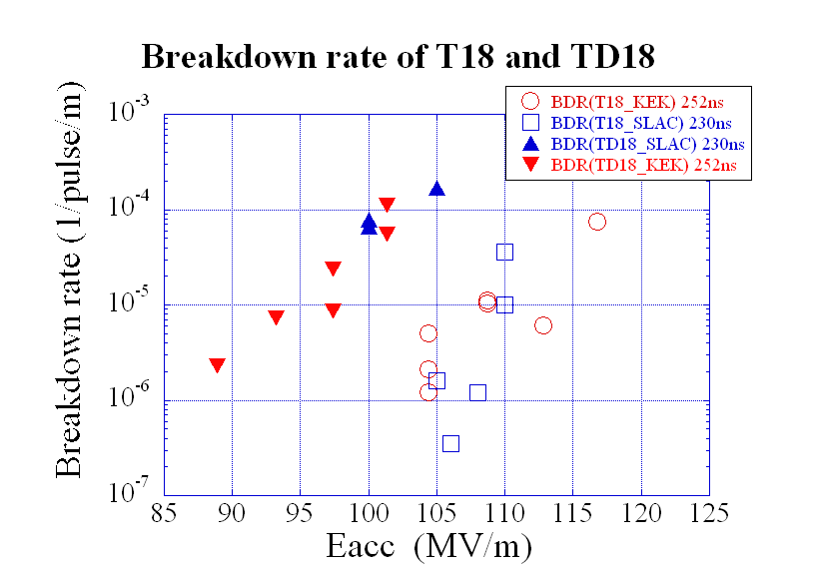
Figure 10: Breakdown rates of twin TD18’s.
Though the Sc parameter for the undamped and damped structure is close, there is a clear difference between them. One of the concerns is the high pulse temperature rise for the damped structure case, where the opening of the damping waveguide makes the local enhancement of the magnetic field. The temperature rise increases as pulse width. The typical example of the BDR vs. width is shown in Fig. 11. The dependence on pulse heating temperature rise to the BDR is more clearly shown in an experimental data performed in one of the twin structures of TD18 tested at SLAC [20,21].
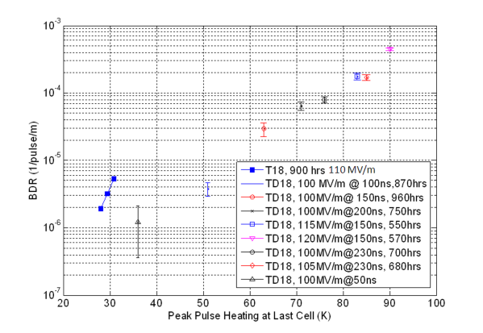
Figure 11: Breakdown rates of T18 and TD18 vs. pulse temperature rise.

Supplementary Basic Studies
There are many study works on-going in the simpler setups, such as DC breakdown test, high gradient test with waveguides, single-cell configuration and pulse heating test setup. These are usually easier to conduct, cheaper and faster and hopefully more directly accessible to physics because of much simpler system. These are covered by the talk of V. Dolgashev [14]. These tests are critical and supplementing the tests with prototype structures.

further efforts

Design Parameters
With varying the cell shape and parameters along the structure, some designs with much lower ΔT exist. In Fig. 12 is shown the comparison between TD18 already tested and the CLIC nominal design, TD24, with reduced ΔT which is to be tested soon [22].
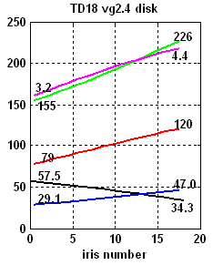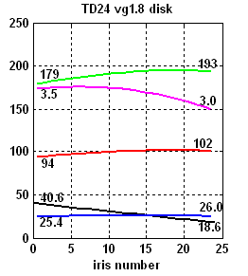
Figure 12: Accelerator mode parameters of TD18 and TD24. Black=power, Red=acceleration gradient, Green=surface electric field, Purple=square root of Sc and Blue=ΔT.
Since many 60cm HDDS structures worked well at 65 MV/m level and even at 100 MV/m in H75 structure, it is worthwhile to study the DDS possibility for CLIC. A design effort to realize with DDS scheme has started [23] as shown in Fig. 13, where the E and H fields on the surface of one octant of a cell are shown. Another design effort is also on-going, as shown in the same figure, based on choke-mode design with much lower ΔT [24]. The high gradient test is also foreseen in two years or so.
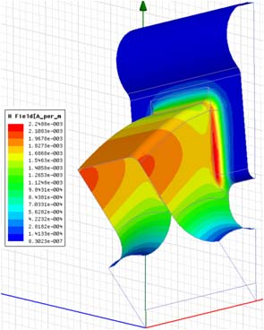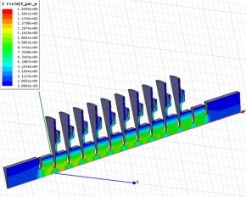
Figure 13: Left=Hs in DDS design and right=choke-mode test structure stack.

Critical Studies in Near Future
As the feasibility study for the stable operation under a high gradient of the order of 100 MV/m, the effort is focusing now on the evaluation of TD24 structure, which was designed to have much lower pulse heating temperature rise along the structure. The pulse temperature rise reduced from 47 degC in TD18 to 26 degC in TD24 by carefully choosing the accelerator shape parameters. The test on the undamped T24 will be performed soon followed by the damped TD24 test, planned in this year.
If TD24 does not show the improved performance compared to TD18, we may need to reconsider the design principle for high gradient and may pursue the serious high gradient evaluations including such structures as DDS or choke-mode scheme.

conclusion
The operation of CLIC prototype structures at 100 MV/m was proved for the undamped structures. The heavily damped structures show higher BDR than those of undamped ones. A design to reduce the pulse temperature rise was made and the high gradient tests will soon be performed in two places. The result will be a crucial evaluation toward the CLIC 100 MV/m acceleration.

acknowlegments
The X-band R&D for linear collider use has been studied for more than 20 years since late 1980. The author would like to respect the early innovative developments by Russian people in VLEPP and thank the managements of KEK and BINP, Protovino, for realizing the collaboration.
The author greatly appreciates the many-year collaboration formalism established between SLAC and KEK under the International Study Group, ISG. He would like to express sincere thanks for the DG’s of both laboratories for encouraging the collaboration.
Now the collaboration is widened among CERN-SLAC-KEK including many other related institutes. He believes that this has greatly promoted and still very essential to judge the design and feasibility confirmation of the normal conducting linear colliders. The author greatly acknowledges the top management, especially Profs. J-P. Delahaye of CERN, T. Raubenheimer of SLAC and A. Suzuki of KEK, for supporting it.

References
[1] V. Balakin, “VLEPP”, Proc. LC91, BINP, Protvino, USSR, Sep. 1992.
[2] International Study Group Progress Report, KEK Report 2000-7, SLAC R-559, April 2000.
[3] C. Adolphsen, “Advances in Normal Conducting Accelerator Technology from the X-Band Linear Collider Program,” SLAC-PUB-11224, June, 2005.
[4] J.-P. Delahaye, “Towards CLIC Feasibility”, IPAC’10, Kyoto, May 2010, FRXCMH01.
[5] T. Higo et al., “High Gradient Performance of X-band Accelerating Sections for Linear Colliders”, Particle Accelerators, 1994, Vol 48, pp.43-59.
[6] H. H. Braun, “Towards a Multi TeV Linear Collider; Drive Beam Generation with CTF3”, APAC07, Indore, India, 2007.
[8] T. Higo et al., “Advances in X-band TW Accelerator Structure Operating in the 100 MV/m Regime”, IPAC’10, Kyoto, May 2010, THPEA013.
[9] F. Le Pinpec, “Surface Studies and Autopsy of Structures”, ISG8, SLAC, 2002, http://www-project.slac.stanford.edu/lc/ilc/ISG_Meetings/ISG8/nlcisg8.htm
[10] C. Adolphsen, LC02, SLAC, 2002, http://www-conf.slac.stanford.edu/lc02/Default.htm
[11] J. Wang and T. Higo, “Accelerator Structure Development for NLC/GLC“, ICFA Beam Dynamics News Letter No.32, pp27-46, December 2003.
[12] J. Wang et al., “Fabrication Technologies of the High Gradient Accelerator Structures at 100MV/m Range”, IPAC’10, Kyoto, May 2010, THPEA064.
[13] A. Grudiev et al., “New local field quantity describing the high gradient limit of accelerating structures”, PRST-AB, 12, 102001 (2009), p102001-1.
[14] V. Dolgashev, “Study of Basic Breakdown Phonomena in High Gradient Vacuum Structures”, FR105, in this conference.
[15] T. Shintake, “Status Report on Japanese XFEL Construction Project at Spring-8”, IPAC’10, Kyoto, May 2010, TUXRA02.
[16] J. Huopana et al., “Studies on High Precision Machining of CLIC RF structures”, MOP103, in this conference.
[17] S. Tantawi, “SLAC Test Facilities”, 4th Annual X-band Structure Collaboration Meeting, CERN, May 2010, http://indico.cern.ch/conferenceDisplay.py? confId =75374
[18] S. Matsumoto et al., “The Status of Nextef; the X-band Test Facility in KEK”, Proc. LINAC’08, THP053, Vancouver, Canada, 2009.
[19] K. Shirm, “CERN X-band Test Stand”, 4th Annual X-band Structure Collaboration Meeting, CERN, May 2010, http://indico.cern.ch/conference Display.py?confId=75374
[20] S. Doebert, et al., “First High Power Tests of CLIC Prototype Accelerating Structures with HOM Waveguide Damping”, LINAC’10, MOP067, this conference.
[21] F. Wang and C. Adolphsen, F. Wang and C. Adolphsen, “TD18 High Power Test Results”, 4th Annual X-band Structure Collaboration Meeting, CERN, May 2010, http://indico.cern.ch/ conferenceDisplay.py?confId=75374
[22] A. Grudiev, “Summary of the test structure design”, ibid.
[23] R. Jones, “A Test Structure for CLIC Utilizing Damped and Detuned Wakefield Suppression and Optimized Surface Field”, LINAC’10, MOP002, this conference.
[24] J. Shi, private communication.

